The online store comes, with a built-in blogging engine, blogging is an excellent way to build your audience and generate more traffic and sales for your business, setting up a block can help you make an around your products and your brand.

**Add a blog to your online store**

You can add blogs to your online store, and then post to the blogs to update your customers about your business or products Blog posts drive traffic to your site in several different ways:

* Improve your store's SEO.
* Let you tell stories that convert visitors into customers.
* Increase customer engagement.

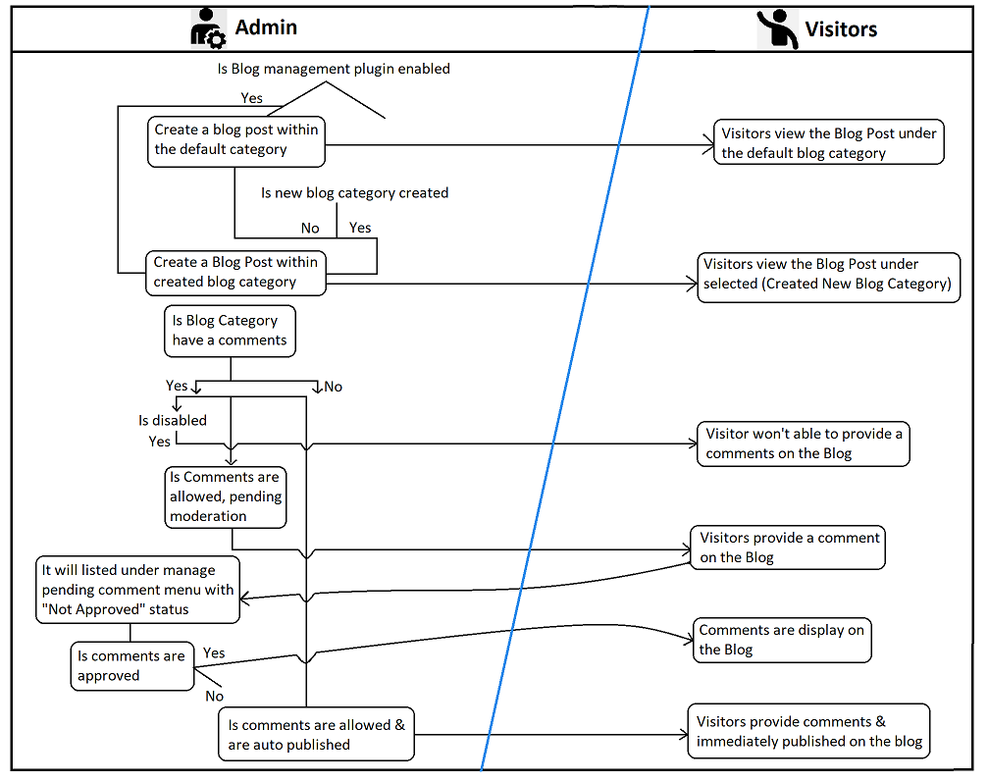

**Plugin Settings**

As a admin, I should be able to enable Blog Management in our plugins. So that, I can able to create blog and manage blog on my store.

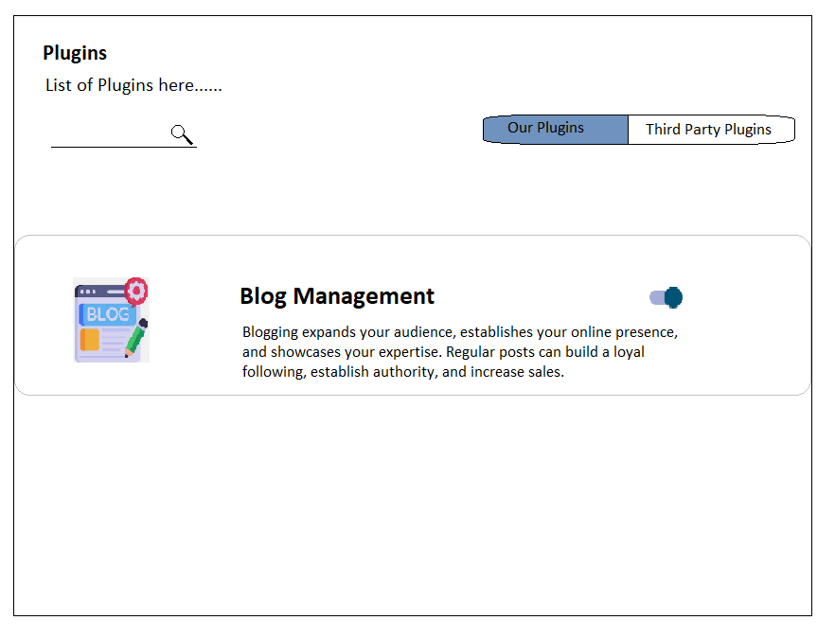

# **Blog Post**

## **Landing Page**

Blog Management> Blog Post

As a admin, I should be able to view landing page, when I am opening newly in blog post sub menu under Blog Management menu.

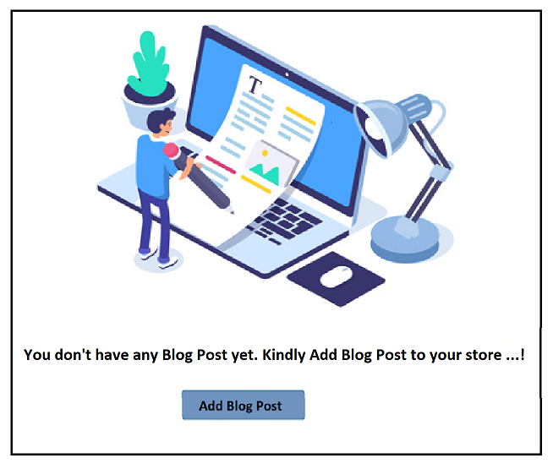

## **Blog Post List Page**

Blog Management> Blog Post

The Blog list page should contain Searchlt field, fiers, Sorting,Add blog post button, and the blog post list.

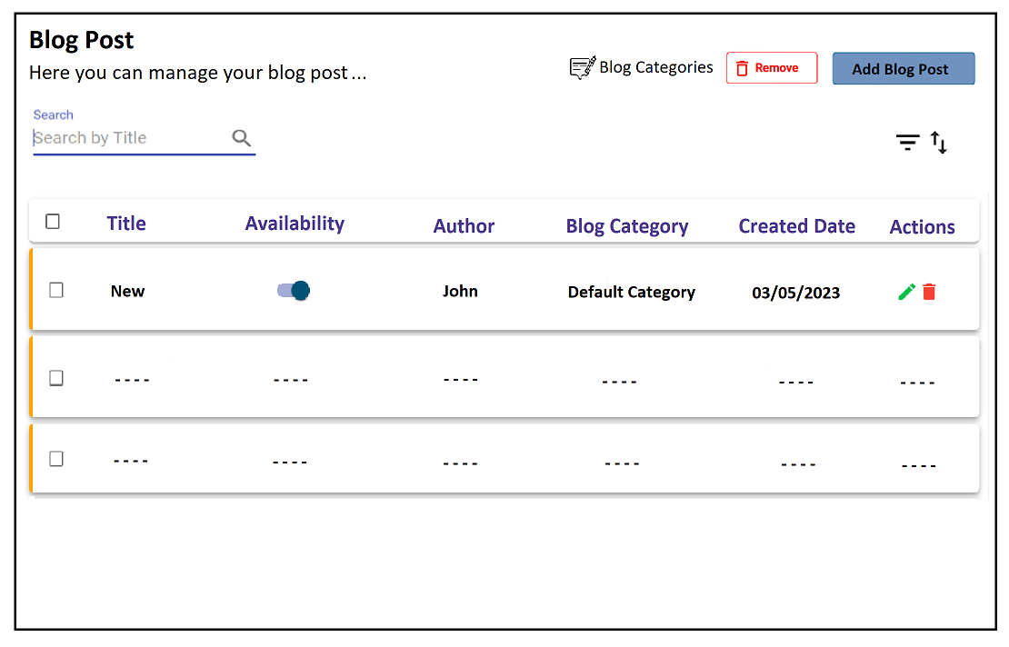

| **S.No** | **Fields** | **Type** | **Options/Conditions** | **Description** |
| --- | --- | --- | --- | --- |
| 1. | Search | Text Field | Title as placeholder text | The searched blog post will be displayed |
| 2. | Filter | Dropdown(Availability Blog category, Author, Custom Date)  Radio button(Availability)  Radio button(Blog category)  Search and single select(Author)  Date picker(Custom Date>Date range)  Size(Custom Date>This year, Last Year, Lifetime) | There are four filters:   * Availability * Blog category * Author * Custom Date   “Availability” should contain following options,   * Enabled * Disabled   (All options should be “Radio button”)  (“Blog category” options should be “Radio button”)  (“Author” options should be “Radio button”)  “Custom Date” should contain following options,   * Date range(Date picker) * This Year(Size) * Last Year(Size) * Lifetime(Size) | Reset Filter & Close button available at the filters header.After filtering the options in Availability/ Blog category/ Author/ Custom Date, “Apply” button and Individual “Reset” icon will be shown.After clicking “Apply” button, the appropriate result will shown in the list page. |
| 3. | Sort | Dropdown | The options are,   * Blog Post Title (A-Z) * Blog Post Title (Z-A) * Blog Category Title (A-Z) * Bolg Category Title (Z-A) * Author (A-Z) * Author (Z-A) * Last Modified * First Modified * Created First * Created Last | “Created First/Blog Post Title (A-Z)” should be the default option. When selecting one of the sort’s options, the appropriate result will be shown in the list page. |
| 4. | Add blog Post | Button |  | To create a blog post using the “Add blog Post” button |
| 5. | Table Title |  |  | Title, Availability, Author,Blog Category,Created Date, Actions - bulk edit, Edit, Delete |
| 6. | Bulk Action |  | Bulk Delete | Bulk Action |
| 7. | Edit | Icon | When you have edited the blog, change the blog title, and change the description, after you have saved, the changes will be updated. |  |
| 8. | Delete | Icon |  | To delete the blog post |

## **Create your first blog post**

As an Admin, I should be able to create a new blog by clicking “Add Blog Post” button. So that, I can able to excellent way to build my audience and generate more traffic and sales for my business.

Blog Management> Blog Post> Add Blog Post

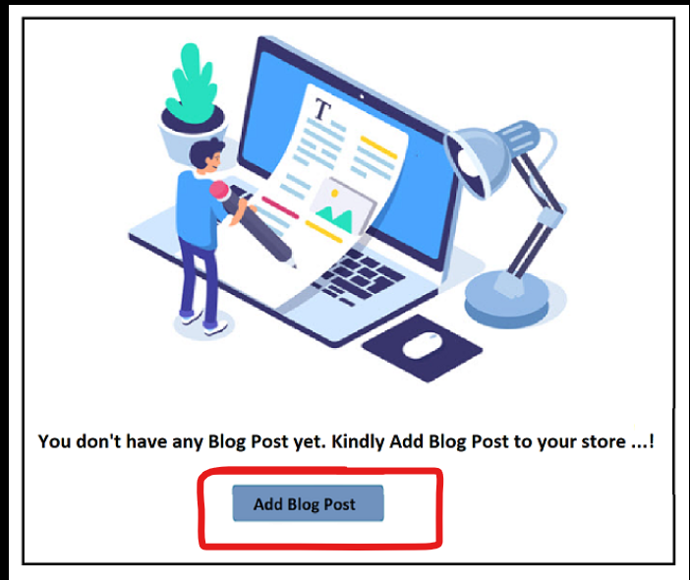

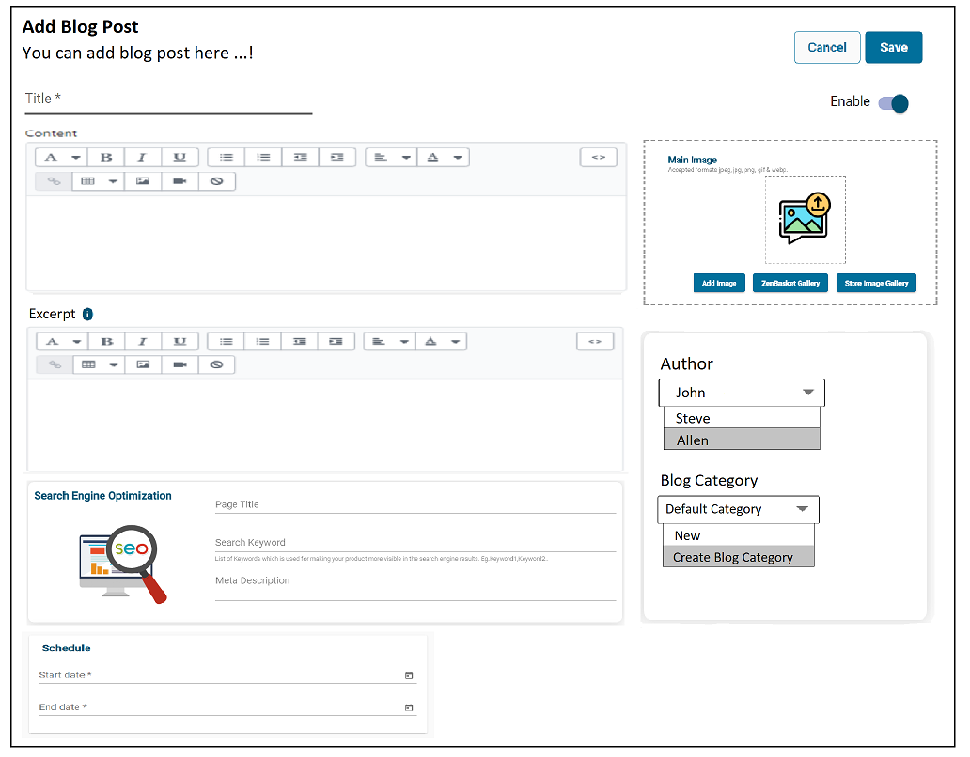

| **S.No** | **Field** | **Type** | **Description** | **Validation** | **Validation message** |
| --- | --- | --- | --- | --- | --- |
| 1. | Title | Text Field | Enter a title for the blog post | Required | Title name is required |
| 2. | Content Formatting | Text Formatting Tools | This field uses the rich text editor, so I can format my post content. I can also add an image, embed a video or other media, or insert a link.   * Formatting * Bold * Italic * Underline * Bulleted list * Numbered list * Outdent * Indent * Alignment * Left align * Right align * Center align * Color (text and background) * Insert Link * Insert table * Insert image * Insert video * Clear formatting * Show HTML code * Blockquote |  |  |
| 2.a) |  | A Pop up will open, if “Insert Link” was chosen, | | | |
|  | **Insert Link**>Link to | Text Field | Paste the blog link | Required |  |
|  | **Insert Link**>Open this link in | Drop down | The options are:   * Same Window * A New Window |  |  |
|  | **Insert Link**>Link title | Text Field | Enter the link title |  |  |
|  | “Save”, and “Cancel‘ | Button |  |  |  |
|  | Close | Icon |  |  |  |
| 2.b) |  | Below options will appear, if “Insert table” was chosen, | | | |
|  | Insert table> | Selectable | Add/update table format and then add a text within a table.  The options are:   * Insert row above * Insert row below * Insert Column before * Insert Column after * Delete row * Delete column * Delete table |  |  |
| 2.c) | Insert image>Add Image | Button | I should be able to upload image from Add image(my computer), ZenBasket Gallery and Image Gallery.  Image Limitation: upto 10 images.  Image Size(can't exceed): 20 megapixels, 20 megabytes.  Advanced: Uploading image by pasting image url. |  |  |
|  | Insert image>Add alt text for the Image | Text Field | I should be able to add alt text for the uploaded image |  |  |
|  | Insert image>Edit Image | Icon | click the image and Edit, to give some spacing in the left, right, top, and bottom alignment, then click the “Edit image” button, and changes will be updated. |  |  |
|  | Insert image>Remove Image | Icon |  |  |  |
| 2.d) |  | A Pop up will open, if “Insert video” was chosen, | | | |
|  | Insert video |  | To upload video to the blog, go to the you tube, select the video which you want to upload the blog, play it and click share icon, then click the embed icon button, copy the embed code and paste it in the insert video pop up.  If you're uploading video files, then make sure the requirements:   * Video length: Up to 10 minutes * Video size: Up to 1 GB * Video resolution: Up to 4K (4096 x 2160 px) * Video file type: .mp4 or .mov   Note: Insert a video by pasting the embed snippet in the box below. |  |  |
|  | “Save”, and “Cancel‘ | Button |  |  |  |
|  | Close | Icon |  |  |  |
| 3. | Add a Featured Image |  | The main image will display the landing page of the blog/Featured image will show all thumbnail previews and list sections of the blog |  |  |
|  | >Add Image | Button | I should be able to upload image from Add image(my computer), ZenBasket Gallery and Image Gallery.(One image at a time)  Note : An image size of 918px x 483px is ideal(Dukaan) |  |  |
|  | Insert image>Add alt text for the Image | Text Field | I should be able to add alt text for the uploaded image |  |  |
|  | Insert image>Edit Image | Icon | Edit image, I can add the image alt text in this text field |  |  |
|  | Insert image>Remove Image | Icon |  |  |  |
| 4. | Excerpt |  | Add a summary of the post to appear on your home page or blog.  I can display excerpts from a blog post on the blog landing page(it will display below the main image and blog title on the storefront). I can be able to include images, text formatting, and links in my excerpt.  This field uses the rich text editor, so Ican format my post content. I can also add an image, embed a video or other media, or insert a link. |  |  |
| 5. | SEO | Link  Title - Text Field  Description - Text Box  URL - Text Field | Click on edit SEO, I can edit the page title, description and page URL  Defaultly, Title should be as a blog title and url as blog url.  Title- Auto filled based on the “Blog Post Title”  Description - Auto filled based on the “Content”(upto 320 characters used)  URL - Auto generate the url based on the blog title. |  |  |
| 6 | Availability | Toggle | Blog posts are hidden by default. When ready to publish the post, then enable the toggle button. |  |  |
| 7 | Schedule | Date picker  Time Picker | set a specific publishing date and time for the post.(You can schedule only when the blog post availability status is hidden) |  |  |
| 8. | Other details | | | | |
|  | a)Author | Drop Down | Author selects the name of the person writing the post. Only the names of the store owner and staff appear in the drop-down menu. |  |  |
|  | b) Blog category | Drop Down | The online store has a default blog called “Default Category”, I can keep this blog, or I can create my own with a custom name |  |  |
|  | “Create new blog”>Blog Title | Text Field | I can create my own with a custom name by clicking “Create new blog” link, and enter the blog title. After saving the blog post, the given Blog title will be displayed in the **“Manage blogs”** sub menu. Blog title display above the main image on the storefront. | Required (once i click create new blog) | Blog title is required |
| 9. | Theme template | Dropdown | Assign a template from your current theme to define how the blog post is displayed. |  |  |
| 10. | Save | Button | The success pop up should be, “The new blog post created successfully” with Okay |  |  |
| 11. | Cancel | Button | The warning pop up should be, “Are you sure, you want to leave this page” with “Yes”, “No” |  |  |

Add blog post>Content Formatting>**Insert Link**

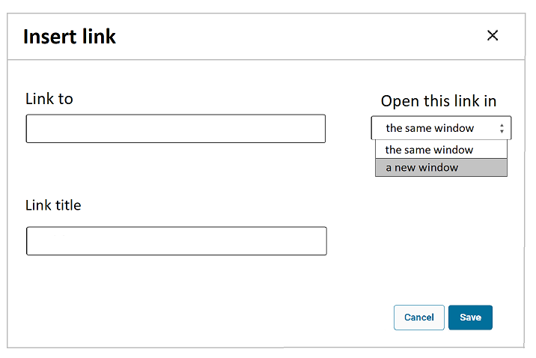

Add blog post>Content Formatting>**Insert Table**

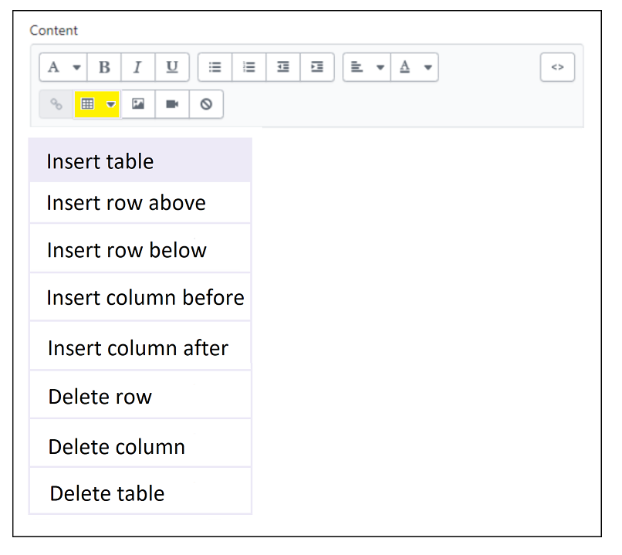

After adding row and columns

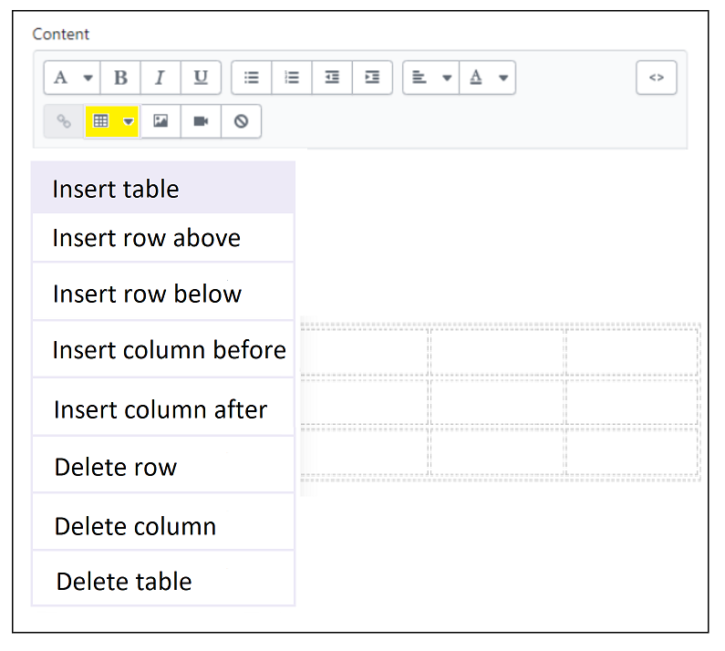

Add blog post>Content Formating>**Insert Imge**

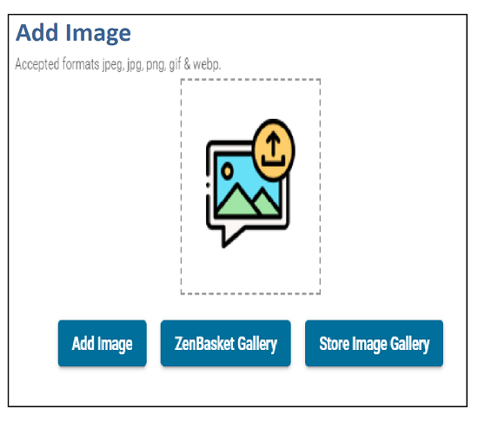

Edit image

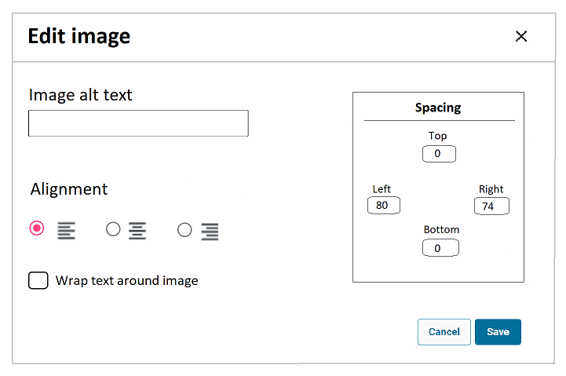

Add blog post>Content Formating>**Insert Vidoe**

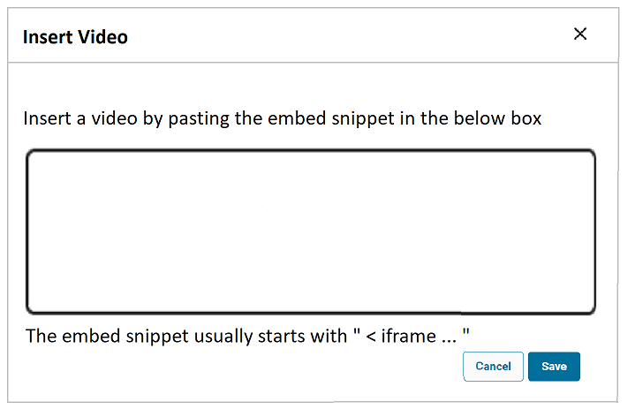

After placing embed text

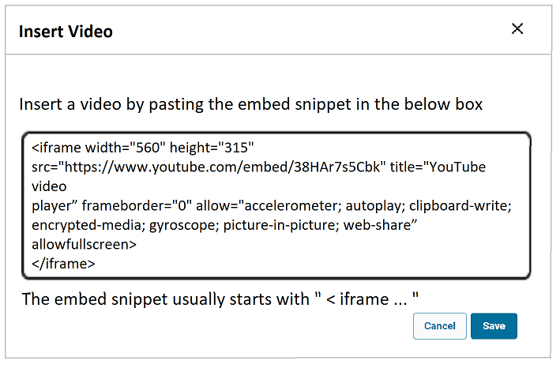

## **Edit Blog Post**

As an Admin I should be able to edit an existing blog post to change the Title, content, publish date, author, or other blog post details,

Make your changes to the existing content and Click Save.

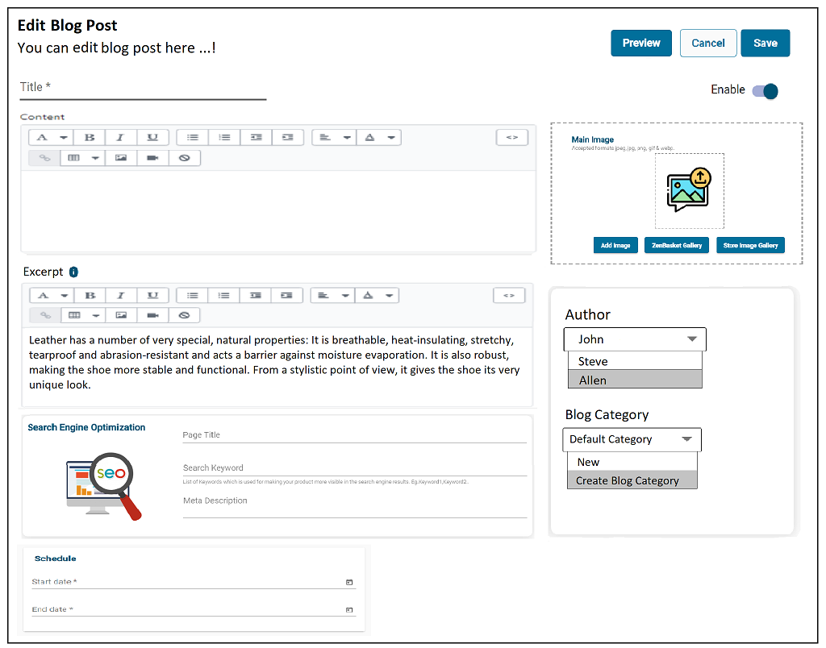

| **S.No** | **Field** | **Type** | **Description** | **Validation** | **Validation message** |
| --- | --- | --- | --- | --- | --- |
| 1. | Title | Text Field | Enter a title for the blog post | Reqiured | Title name is required |
| 2. | Content Formatting | Text Formatting Tools | This field uses the rich text editor, so Ican format my post content. I can also add an image, embed a video or other media, or insert a link.   * Formatting * Bold * Italic * Underline * Bulleted list * Numbered list * Outdent * Indent * Alignment * Left align * Right align * Center align * Color (text and background) * Insert Link * Insert table * Insert image * Insert video * Clear formatting * Show HTML code |  |  |
| 2.a) |  | A Pop up will open, if “Insert Link” was chosen, | | | |
|  | **Insert Link**>Link to | Text Field | Paste the blog link | Reqiured |  |
|  | **Insert Link**>Open this link in | Drop down | The options are:   * Same Window * A New Window |  |  |
|  | **Insert Link**>Link title | Text Field | Enter the link title |  |  |
|  | “Save”, and “Cancel‘ | Button |  |  |  |
|  | Close | Icon |  |  |  |
| 2.b) |  | Below options will appear, if “Insert table” was chosen, | | | |
|  | Insert table> | Selectable | Add/update table format and then add a text within in a table.  The options are:   * Insert row above * Insert row below * Insert Column before * Insert Column after * Delete row * Delete column * Delete table |  |  |
| 2.c) | Insert image>Add Image | Button | I should be able to uplaod image from Add image(my computer), ZenBasket Gallery and Image Gallery.  Image Limitation: upto 10 images.  Image Size(can't exceed): 20 megapixels, 20 megabytes. |  |  |
|  | Insert image>Add alt text for the Image | Text Field | I should be able to add alt text for the uplaoded image |  |  |
|  | Insert image>Edit Image | Icon | click the image and Edit, to give some spacing in the left, right, top, and bottom alignment, then click the “Edit image” button, and changes will be updated. |  |  |
|  | Insert image>Remove Image | Icon |  |  |  |
| 2.d) |  | A Pop up will open, if “Insert video” was chosen, | | | |
|  | Insert video |  | To upload video to the blog, go to the you tube, select the video which you want to upload the blog, paly it and click share icon, then click the embed icon button, copy the embed code and paste it in the insert video pop up.  If you're uploading video files, then make sure the requirements:   * Video length: Up to 10 minutes * Video size: Up to 1 GB * Video resolution: Up to 4K (4096 x 2160 px) * Video file type: .mp4 or .mov   Note: Insert a video by pasting the embed snippet in the box below. |  |  |
|  | “Save”, and “Cancel‘ | Button |  |  |  |
|  | Close | Icon |  |  |  |
| 3. | Add a Main image |  | The main image will display the landing page of the blog. |  |  |
|  | >Add Image | Button | I should be able to uplaod image from Add image(my computer), ZenBasket Gallery and Image Gallery.(One image at a time)  Note : An image size of 918px x 483px is ideal(Dukaan) |  |  |
|  | Insert image>Add alt text for the Image | Text Field | I should be able to add alt text for the uplaoded image |  |  |
|  | Insert image>Edit Image | Icon | Edit image, I can add the image alt text in this text field |  |  |
|  | Insert image>Remove Image | Icon |  |  |  |
| 4. | Excerpt |  | I can display excerpts from a blog post on the blog landing page(it will display below the main image and blog title on the storefront). I can be able to include images, text formatting, and links in my excerpt.  This field uses the rich text editor, so Ican format my post content. I can also add an image, embed a video or other media, or insert a link. |  |  |
| 5. | SEO | Link  Title - Text Field  Description - Text Box  URL - Text Field | Click on edit SEO, I can edit the page title, description and page URL  Defaultly, Title should be as a blog title and url as blog url. |  |  |
| 6 | Availability | Toggle | Blog posts are hidden by default. When ready to publish the post, then enable the toggle button. |  |  |
| 7 | Schedule | Date picker  Time Picker | set a specific publishing date and time for the post.(Only when blog post availability status is Hidden) |  |  |
| 8. | Other details | | | | |
|  | a)Author | Drop Down | Author selects the name of the person writing the post. Only the names of the store owner and staff appear in the drop-down menu. |  |  |
|  | b) Bolg category | Drop Down | The online store has a default blog called “Default Category”, I can keep this blog, or I can create my own with a custom name |  |  |
|  | “Create new blog”>Blog Title | Text Field | I can create my own with a custom name by clicking “Create new blog” link, and enter the blog title. After saving the blog post, the given Blog title will be displayed in the **“Manage blogs”** sub menu. Blog title display above the main image on the storefront. | Required (once i click create new blog) | Blog title is required |
| 9. | Comments status | Text with link | I can able to view comments for selected blog category |  |  |
| 10. | Save | Button | The success pop up should be, “The new blog post updated successfully” with Okay |  |  |
| 11. | Cancel | Button | The warning pop up should be, “You have unsaved changes. Are you sure you want to leave this page?” with “Yes”, “No” |  |  |
| 12. | Preview blog | Button | After saving, As an Admin, I should be able to view the blog by clicking “Preview” button. So that, I can able to view how the blog post looks on my website. |  |  |

# **Blog Categories**

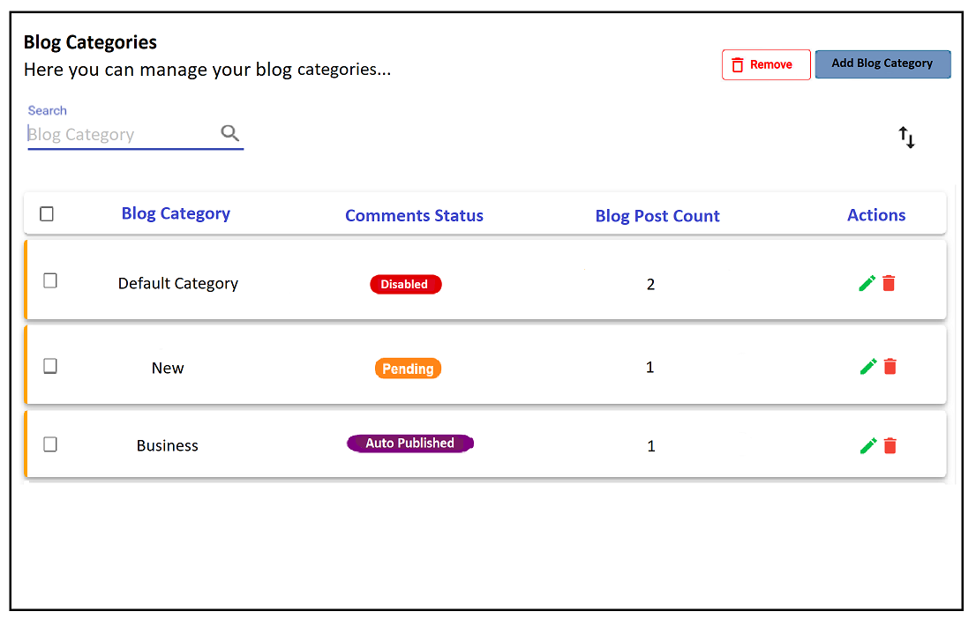

Initially, default category is listed in the list.

While creating blog post the selection of of blog category is “Create new blog” option means, the newly added Blog Title also listed in this page.

## Manage Blog category List

| **S.No** | **Fields** | **Type** | **Options/Conditions** | **Description** |
| --- | --- | --- | --- | --- |
| 1. | Search | Text Field | Blog Category Title as placeholder text | The searched blogs will be displayed |
| 2. | Sort | Dropdown | The options are,   * Blog Category Title (A-Z) * Blog Category Title (Z-A) | “Blog Category Title (A-Z)” should be the default option. When selecting one of the sort’s options, the appropriate result will be shown in the list page. |
| 4. | Add blog | Button |  | To create a blog using the “Add blog” button |
| 5. | Table Title |  |  | Bog Category, Comments Status, Blog Post Count, Actions - Edit, Delete |
| 6. | Bulk Action |  | Bulk Delete |  |
| 7. | Edit | Icon | When you have edited the blog, change the blog title, after you have saved, the changes will be updated to the existing and newly creating blog posts. |  |
| 8. | Delete | Icon |  | To delete the blog |

## **Create Blog category**

As an Admin, I should be able to create a blog category by clicking “Add Blog” button. So that, I can able to categorized the blog post within it.

Blog Management> Blog category> Add Blog Category

Add a blog category, give your blog a title, and then select how you want to manage comments.

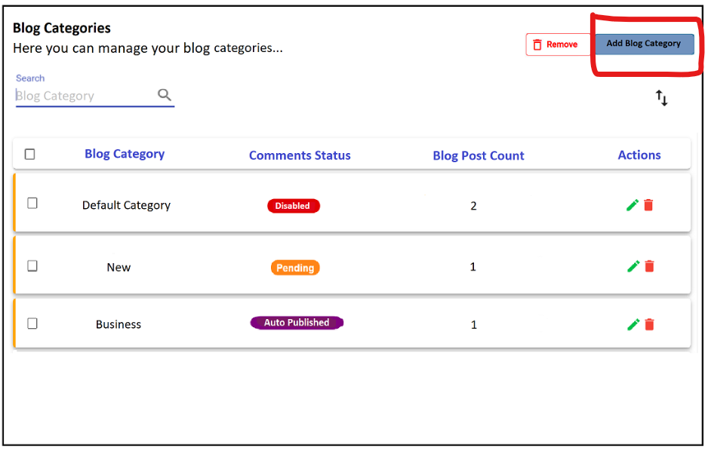

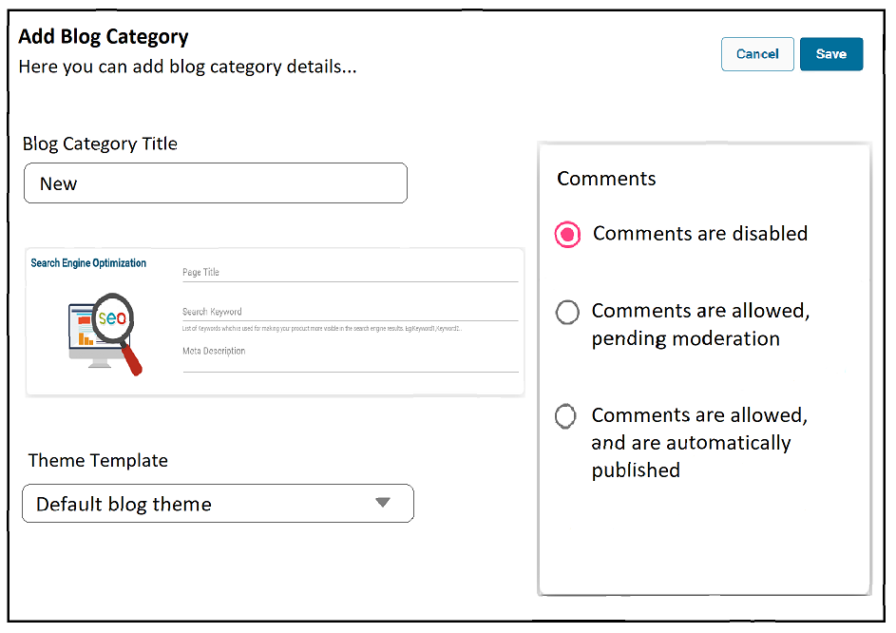

| **S.No** | **Field** | **Type** | **Description** | **Validation** | **Validation message** |
| --- | --- | --- | --- | --- | --- |
| 1. | Blog Category Title | Text Field | Enter a title for the blog category | Reqiured | Blog title name is required |
| 2. | SEO | Link  Title - Text Field  Description - Text Box  URL - Text Field | Click on edit SEO, I can edit the page title, description and page URL  Defaultly, Title should be as a blog category title and url as blog category url.  Title - Auto fetched from Blog category title |  |  |
| 3. | Comments | Radio Button | Comments can provide a place for conversations about your business and products. You can allow customers to comment on your blog posts, disable comments, or allow comments pending moderation.  When you create a new blog, comments are disabled by default.they will not displayed any comments.  The options are   1. Comments are disabled 2. Comments are disabled pending mderation 3. Comments are allowed and automatically disabled |  |  |
| 4. | Category theme template | Dropdown | You have created a custom template for blog categories, you can select a template. In the template drop-down menu, select the template that you want to use for the blog category. All of the posts in the blog category will use the template. |  |  |
| 5. | Save | Button | The success pop up should be, “The blog category created successfully” with Okay |  |  |
| 6. | Cancel | Button | The warning pop up should be, “Are you sure, you want to leave this page” with “Yes”, “No” |  |  |

Once you have created it, the created blog category title shown in the blog post,

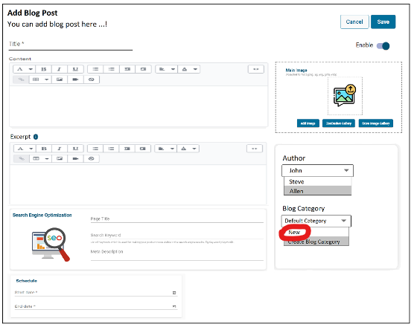

## **Edit Blog Category**

As an Admin I should be able to edit an blog category title,to change the comments checkbox,SEO content,

Make your changes and click save button

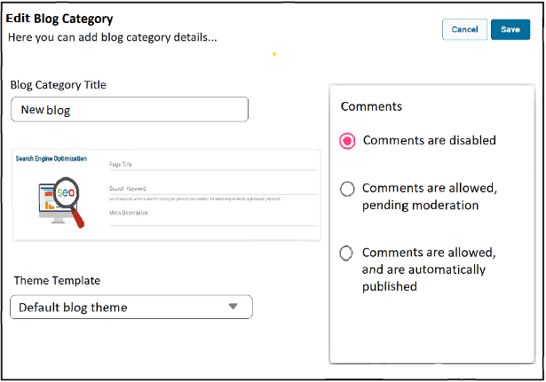

| **S.No** | **Field** | **Type** | **Description** | **Validation** | **Validation message** |
| --- | --- | --- | --- | --- | --- |
| 1. | Blog Category Title | Text Field | Enter a title for the blog category | Reqiured | Blog title name is required |
| 2. | SEO | Link  Title - Text Field  Description - Text Box  URL - Text Field | Click on edit SEO, I can edit the page title, description and page URL  Defaultly, Title should be as a blog category title and url as blog category url. |  |  |
| 3. | Comments | Radio Button | Comments can provide a place for conversations about your business and products. You can allow customers to comment on your blog posts, disable comments, or allow comments pending moderation.  When you create a new blog, comments are disabled by default.they will not displayed any comments.  The options are   1. Comments are disabled 2. Comments are disabled pending mderation 3. Comments are allowed and automatically disabled |  |  |
| 4. | Category theme template | Dropdown | You have created a custom template for blog categories, you can select a template. In the template drop-down menu, select the template that you want to use for the blog category. All of the posts in the blog category will use the template. |  |  |
| 5. | Save | Button | The success pop up should be, “The blog category updated successfully” with Okay |  |  |
| 6. | Cancel | Button | The warning pop up should be, “You have unsaved changes. Are you sure you want to leave this page?” with “Yes”, “No” |  |  |

# **Comments Status on blog posts - Hold**

Comments can provide a place for conversations about your business and products. You can allow customers to comment on your blog posts, disable comments, or allow comments pending moderation.

When you create a new blog, comments are disabled by default.

## **a) Comments are disabled**

Visitors to your blog can't leave comments on posts,

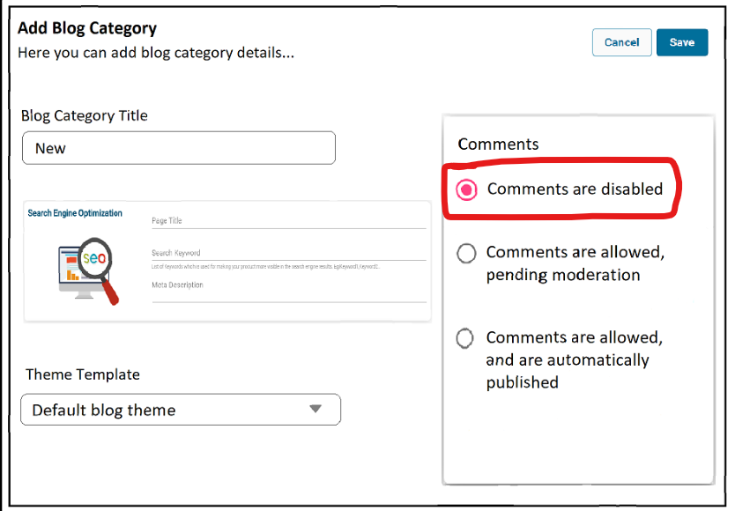

Comments are disabled, then the given comments are notified in the blog post in the “edit blog post”

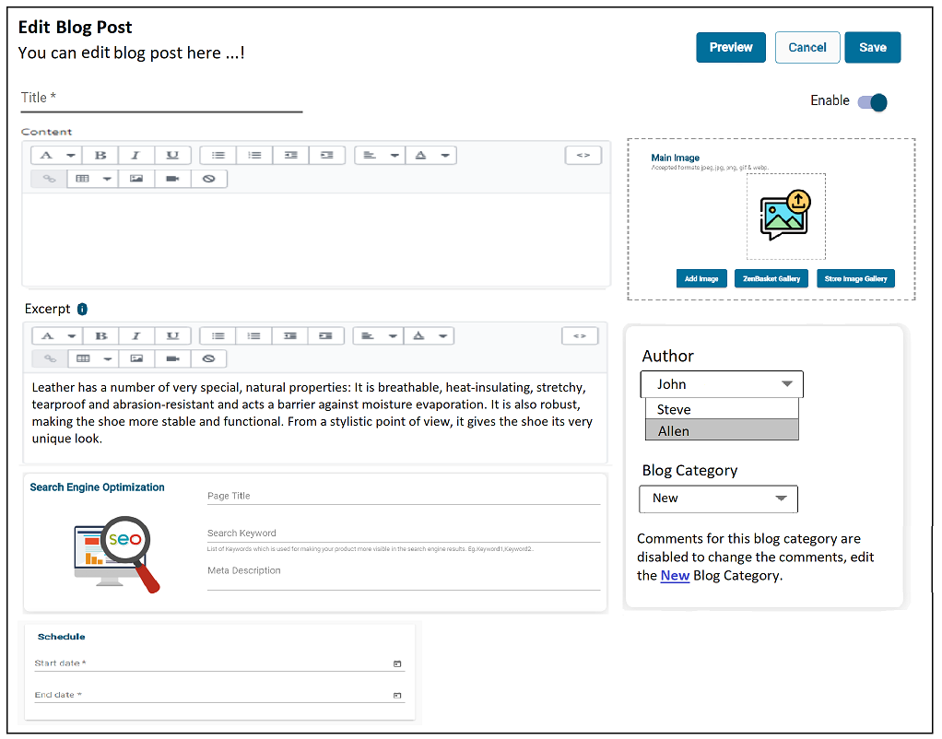

Storefront>>To display blogs on the store without comments,

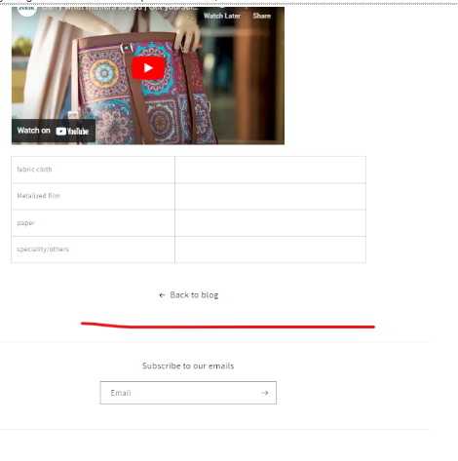

## **b) Comments are allowed pending moderation**

Visitors to your blog can leave comments, but you will need to review the comments before they will appear on your blog.

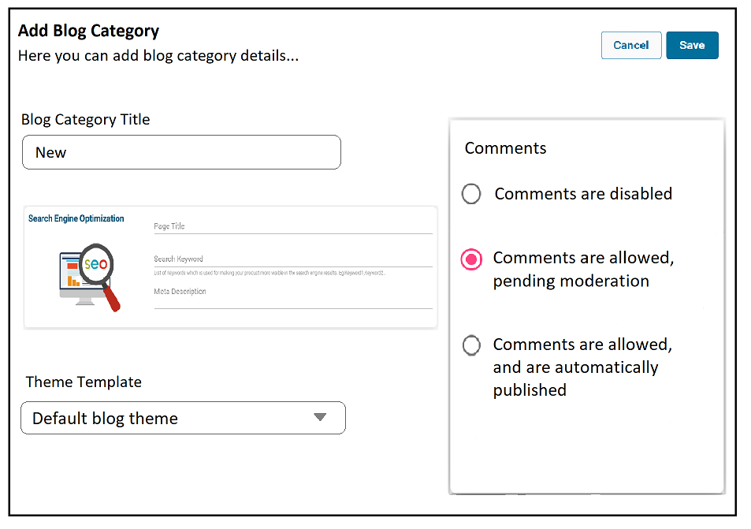

Click Comments are allowed and then click the save button,

Comments are allowed, pending moderation, then the given comments are notified in the “edit blog post”

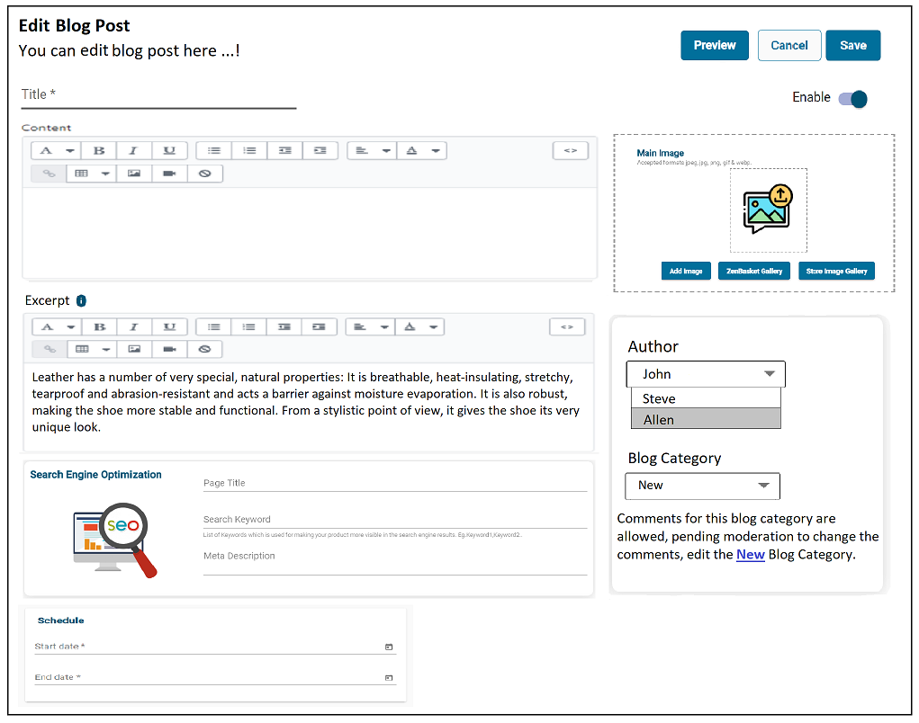

Storefront>>To display blogs on the store Comments are allowed, you have to post the comment,

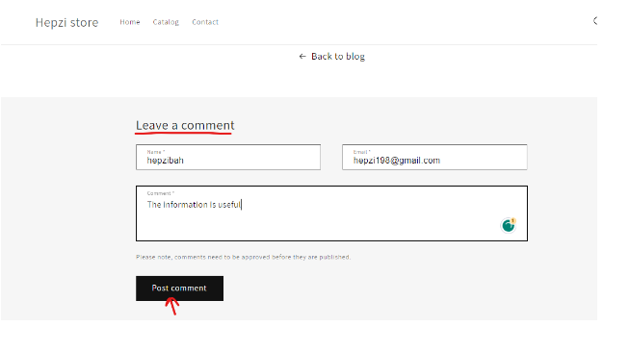

Click the post comment button, and your comments will be posted,

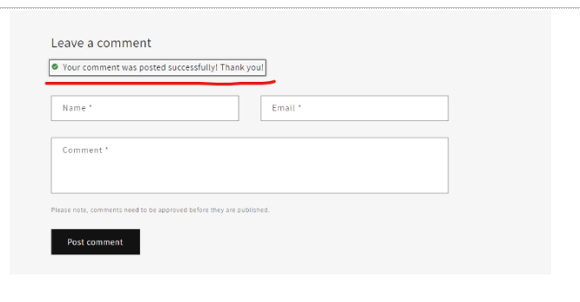

# **Manage pending comments**

When the comments status was set to the blog category as “comments are allowed, pending moderation”.

When a visitors gave any comments on the blog post, the comments’ moderation status will be listed here with “Not Approved” status.

Blog Management>Manage Pending Comments

## **List page**

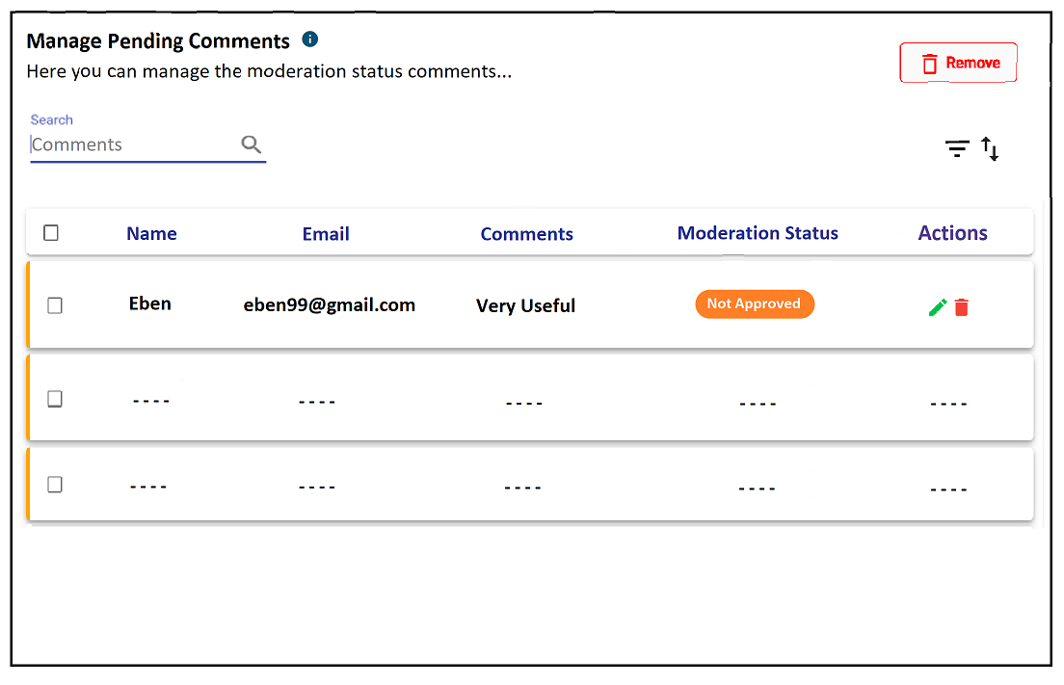

| **S.No** | **Fields** | **Type** | **Options/Conditions** | **Description** |
| --- | --- | --- | --- | --- |
| 1. | Search | Text Field | Comments as placeholder text | The searched comments will be displayed |
| 2. | Sort | Dropdown | The options are,   * Newest First * Oldest First | “Newest First” should be the default option. When selecting one of the sort’s options, the appropriate result will be shown in the list page. |
| 4. | Filter | Radio button(Status) | “Status” should contain following options,   * Approved * Not Approved * Mark as Spam * Unmark as Spam   (All options should be “Radio button”) | Reset Filter & Close button available at the filters header.After filtering the options in Status, “Apply” button and Individual “Reset” icon will be shown.After clicking “Apply” button, the appropriate result will shown in the list page. |
| 5. | Table Title |  |  | Name, Email, Comments, Moderation Status, Actions - Edit, Delete |
| 6. | Bulk Action |  | Bulk Delete |  |
| 7. | Edit | Icon |  |  |
| 8. | Delete | Icon |  | To delete the pending comments. |

For controlling the blog comments, we can have the control at the **global level** as well as for individual **blog** level.

## **Edit Comments**

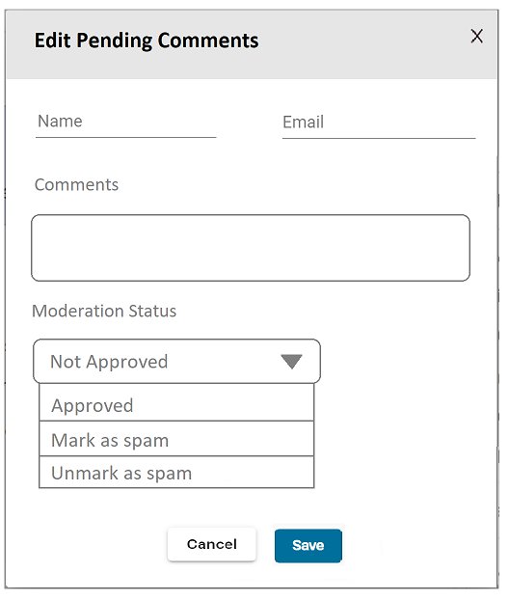

| **S.No** | **Field** | **Type** | **Description** | **Validation** | **Validation message** |
| --- | --- | --- | --- | --- | --- |
| 1. | Name | Text Field | Auto filled based on storefront data | - | - |
| 2. | Email | Text Field | Auto filled based on storefront data | - | - |
| 3. | Comments | Text Area | Auto filled based on storefront data | - | - |
| 4. | Moderation Status | Radio Button | The Moderation status are,   * Not Approved * Approved * Mark as spam * Unmark as spam |  |  |
| 5. | Save | Button | “The Status Updated Successfully” |  |  |
| 6. | Cancel | Button |  |  |  |
| 7. | Close | Icon |  |  |  |

### **b) 1. Approve comments**

To display approved comments on the storefront,

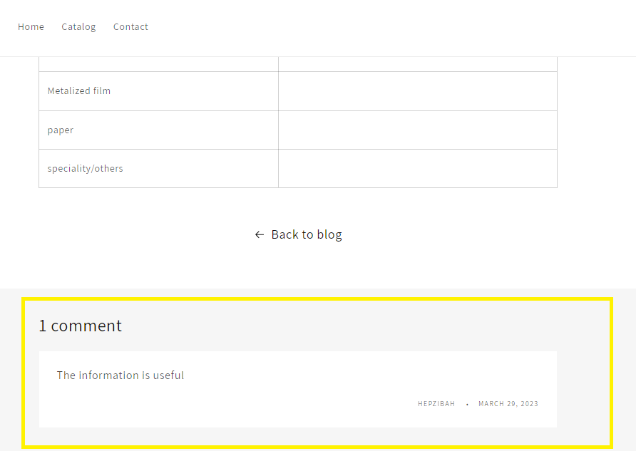

### **b) 2. Mark as spam comments(hide)**

Flagged comments won't be displayed on your blog, but they will appear in your admin. You can mark comments as spam manually.

Note: If a selected comment is mistakenly marked as spam, then you can click Unmark as spam. This will remove the flag and send a notification to ZenBasket to help improve the spam filters.

### **b) 3. Delete comments**

You delete the comments by clicking the remove icon against the comment.

You can also delete multiple comments using a bulk delete action

Sholud show the warning message as “Are you sure you want to remove the selected comments?”

## **4. c ) Comments are allowed, and are automatically published**

Visitors to your blog can leave comments and they will appear on your blog without your review.

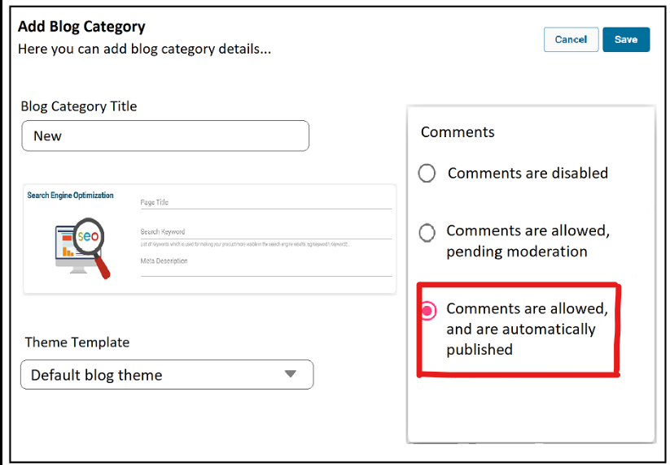

Click the save button, and comments are automatically published,

Comments are allowed and are automatically published, then the given comments are notified in the “edit blog post”

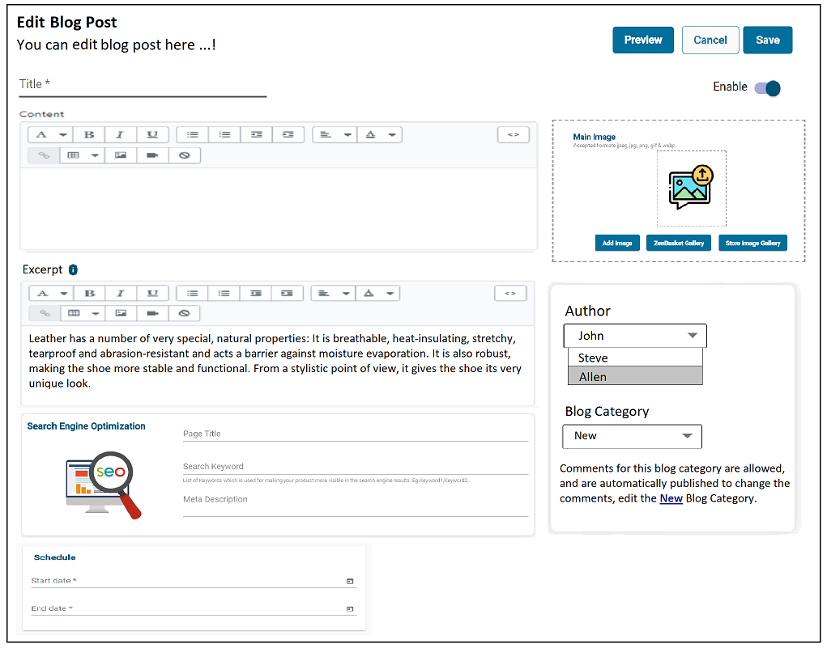

Storefront>>Comments are notified on the blog post page below,

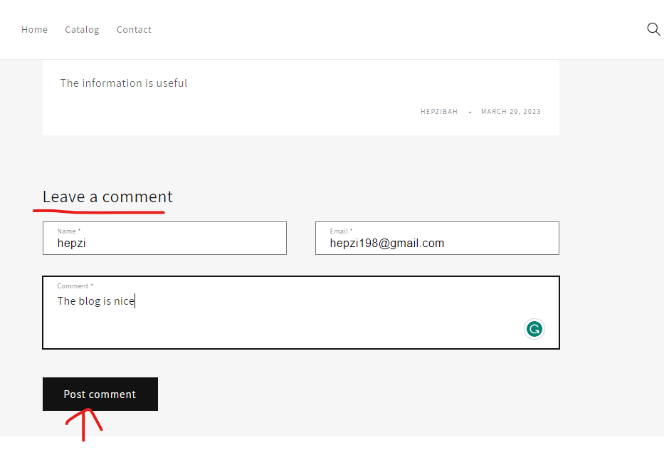

Click the post comment button, the comments are automatically published

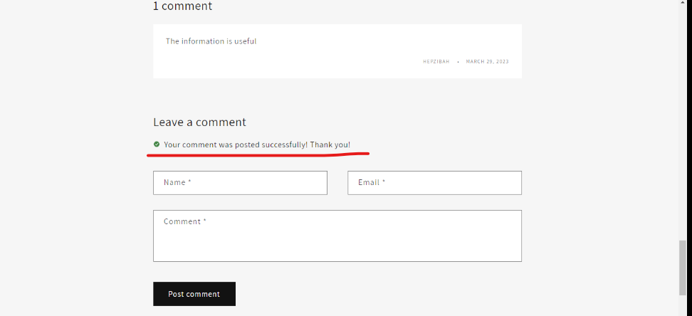

Comments published immediately,

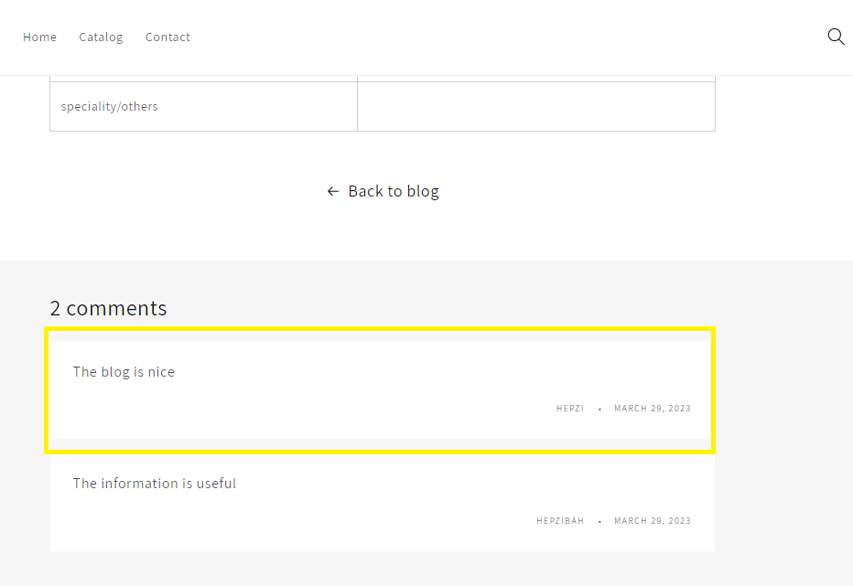

# **Create a new blog template (for customizing the theme)**

You can create a template to customize the layout of all of the posts in a blog. For ex, you could create a template for a blog that will feature a lot of images on posts, and the template is used for all of the posts.

For the blog post, the theme template in the default blog post,

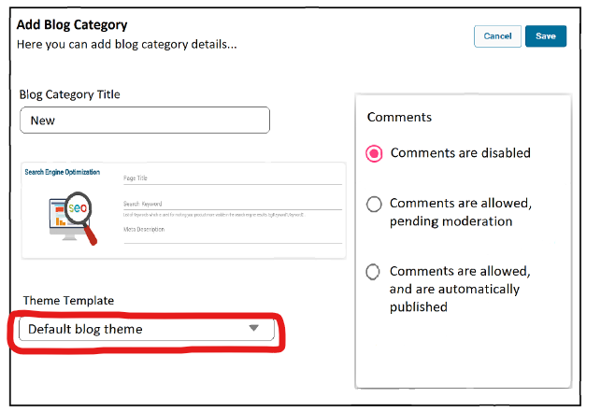

Click customize in the design menu and create a new template for the theme,

1.Select blog post menu

2.Click on the “Create New Template”

3.Enter New Template Name and based on model

4.Click on Save

Template customization:

1.Edit the featured image

2.Show/Hide date and author

3.Change the title and add metafield options

4.Add a new collage multimedia collage section

5.Then add the image banner for this section

6.then add the link in main menu, blog posts to add the url

7.Click on Save

# **Invite customers to subscribe to your blog**

You can include your feed URL in a blog post to invite customers to subscribe to your blog while creating the blog,

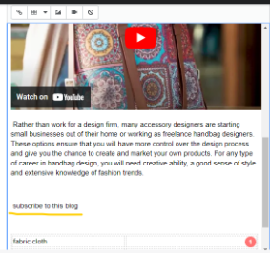

Content formatting>Insert Link>Paste the link url and window selection

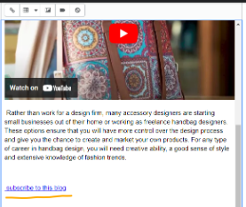

To display storefront ,

